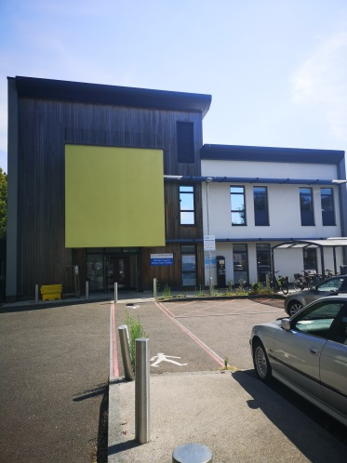

## West Sussex Breast Screening Service

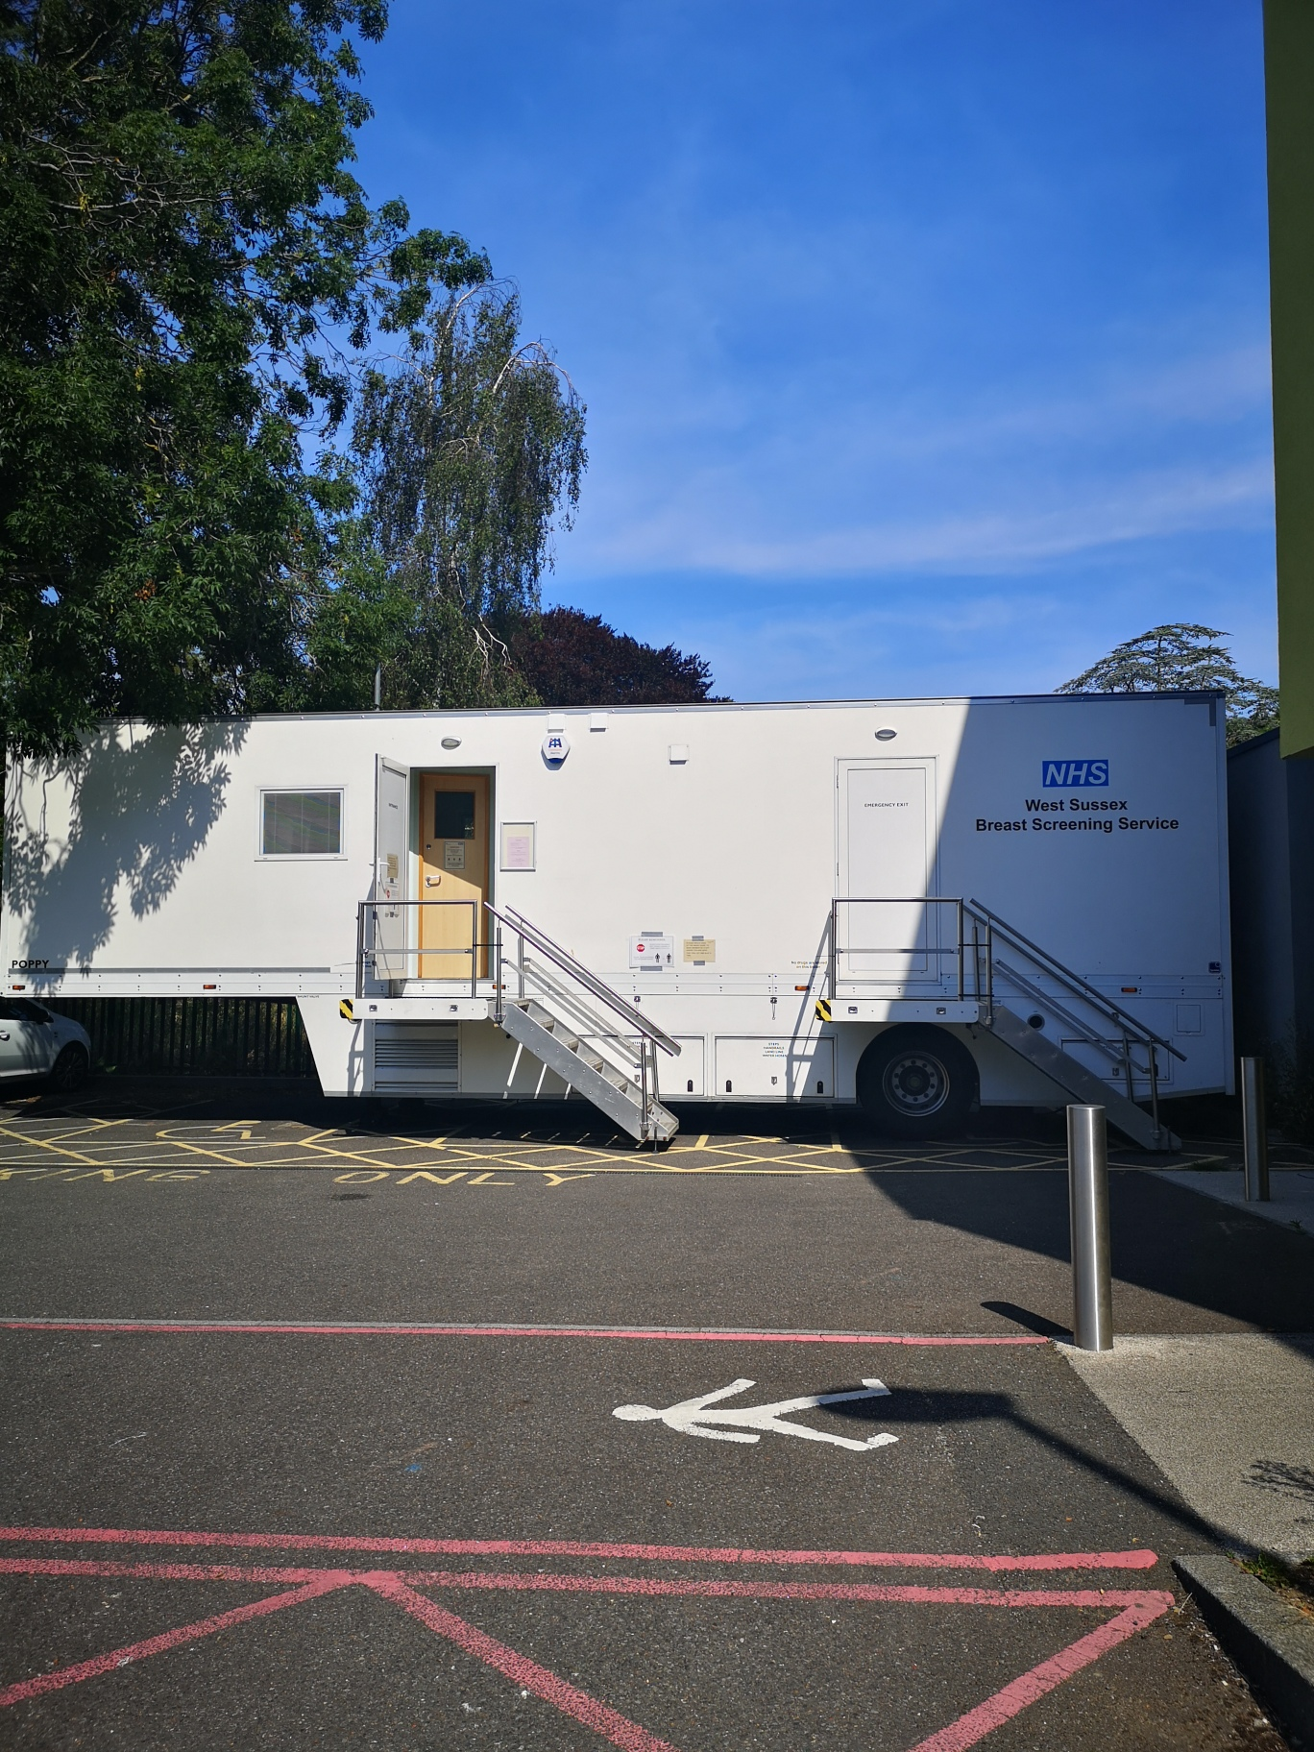

Street Address

Address 2

City, ST ZIP Code

Phone: (725) 555-0125

Fax: (725) 555-0145

E-mail address

# http://img.medscape.com/news/2010/mammography_logo.jpg

The NHS offers breast screening to save lives from breast cancer.

Screening does this by finding breast cancers at an early stage when they are too small to see or feel. Breast screening uses an x-ray test called a mammogram to check the breast for signs of cancer.

The scan is quick and simple and early detection of cancer may often mean simpler and more successful treatment.

Women aged 50 up to their 71st birthday are invited to have breast screening every three years. During the restoration of services following the initial coronavirus outbreak, NHS breast screening  services temporarily paused taking self-referrals from women aged 71 and over. After further review Public Health England have now advised that we can now accept self-referrals for women aged 71 and over.

*Patient feedback from January 2020 – July 2020*

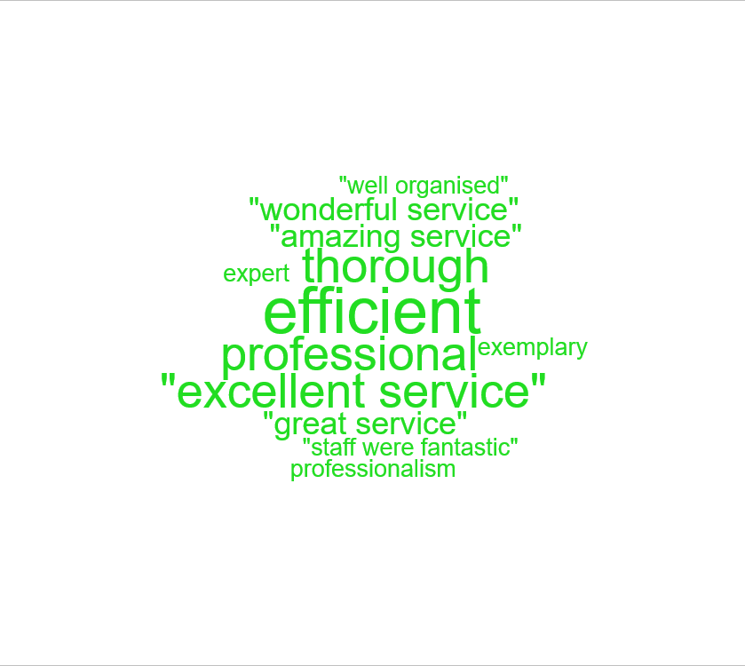

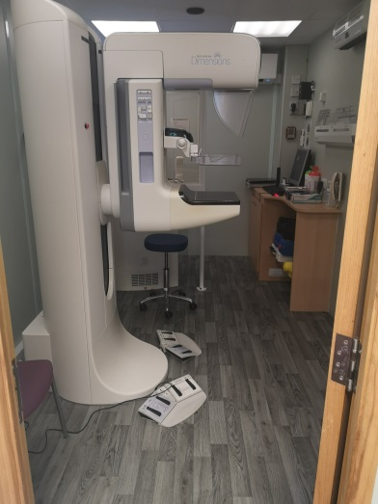

### C:\Users\corbettr002\Pictures\Breast.png

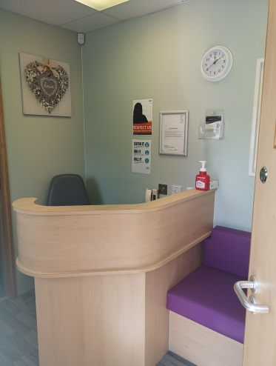

Frequently asked questions

***How will women be invited?***

The Screening Office will send you an invitation letter. The letter will include information about breast screening and a map to show the location of the mobile screening unit.

***Can they change their appointment?***

Yes - they can phone the office on 01903-239757.

***A woman is new to the area. What does she do if she wants a mammogram?***

The Screening Office routinely contacts women who have moved into the area every three months unless their GP practice is about to be screened. She can call the office to check.

***How often can she be screened by the Screening Service?***

Every three years.

***How long does screening take?***

A woman should be on the mobile unit for half an hour or less.

***Does a woman need to do anything?***

She should wear suitable clothing as she will need to undress her top half. She should not wear spray deodorant as this can make tiny marks on the x-rays.

***How soon do results arrive?***

Results should be received within three weeks.

***Should a woman still examine her breasts herself?***

Yes - she should be aware of any changes in her breasts. Breast cancer can develop at any time, including the intervals between screening.

***If she finds a change, who should she tell?***

She should contact her GP who will refer her to see a Breast Surgeon at Worthing Hospital. The Screening Service cannot screen women on demand.

***If you call her back for assessment after screening, what does that mean?***

It usually means that we have seen a change in her x-rays compared with those taken last time. The majority of women recalled do not have cancer. However, the films may not give a complete answer and further investigation is sometimes needed.

***What will happen at assessment?***

Some extra mammograms may be taken. She will then see a senior specialist doctor who will undertake a clinical examination and possibly an ultrasound.

***What happens then?***

The majority of women are found to be normal at this stage. Some women may need a biopsy to help with a diagnosis. This is sometimes done at the assessment appointment but most women will need to come back on another day.

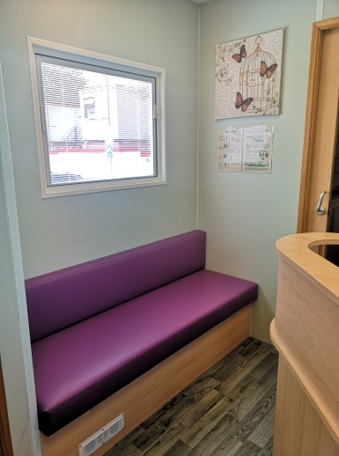

West Sussex Breast Screening Service

Worthing Hospital

Lyndhurst Road

BN11 2DH

Phone: 01903 239757

Email: [wshnt.westsussexbreastscreening@nhs.net](mailto:wshnt.westsussexbreastscreening@nhs.net)

Facebook: @WestSussexBreastScreeningService